Processing a Promotion – No Transfer With or Without Pay Increase Quick Reference Guide
Last Updated: 10/23/2018

Contents
What is a Promotion – No Transfer with Pay Increase? 1
Promotion – No Transfer with Pay Increase Process 1
Access SuccessFactors 1
Searching for an Employee 2
Taking Action 2
Changing Job Information 3
Changing Compensation Information 4

What is a Promotion – No Transfer with or without Pay Increase?
A Promotion refers to a reclassification of a position to a higher job level. The position will generally have a higher level of responsibility or required skill.

Promotion – No Transfer with or without Pay Increase Process
The Initiator will process the Promotion – No Transfer with Pay Increase Process. Once complete, it will be routed to the Department Head and Budget Approver. If necessary, it will also be routed to HR Compensation for additional approval.

Access SuccessFactors
Visit OneCampus and select Employee Launchpad or from the Employee Self-Service web page click SuccessFactors  Log in using Purdue Career Account ID and Password. | https://one.purdue.edu/  https://www.purdue.edu/hr/global/pgnew.php  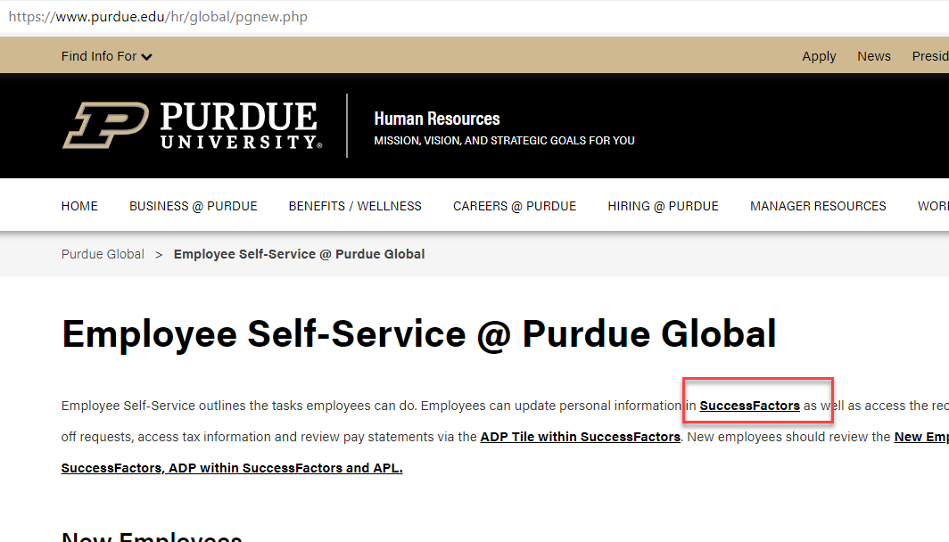
From the SuccessFactors home page, type the name of the employee in the Search field on the navigation bar.

Searching for an Employee
As the employee’s name is being typed, multiple matches may be displayed.  Scroll down to the correct employee’s name and click to select. | 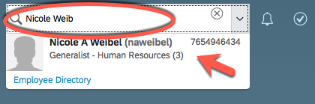
This will display the employee’s Employee File. | 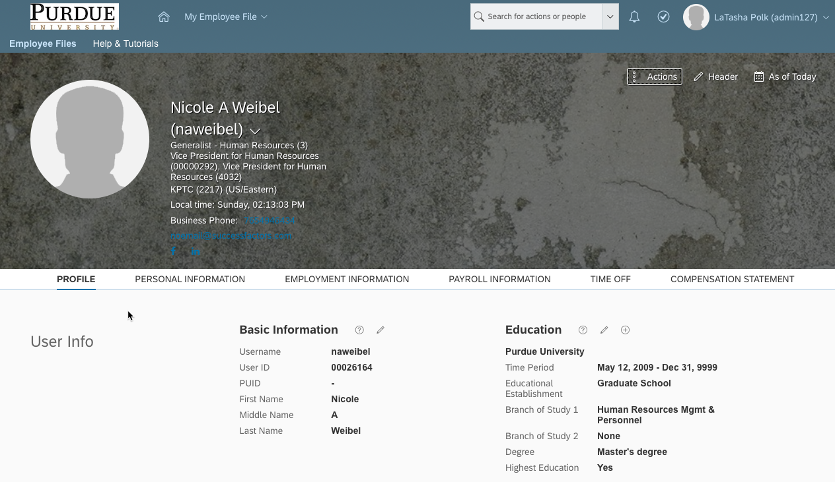

Taking Action
On the Employee File, click on Actions to display drop down menu and select Change Job and Compensation Info. | 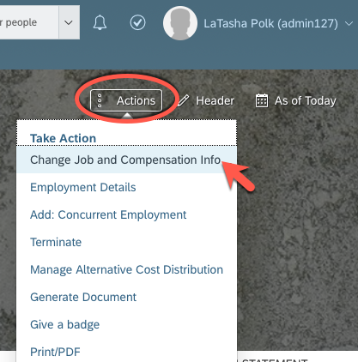
The Change Job and Compensation Info box is displayed.  Check the boxes next to Job Information and Compensation Information. | 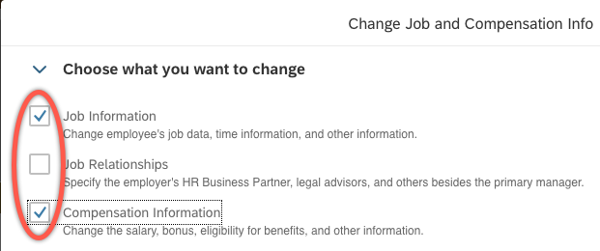
Select the date the effective date by clicking the Calendar icon or by manually entering the date (MMDDYY). | 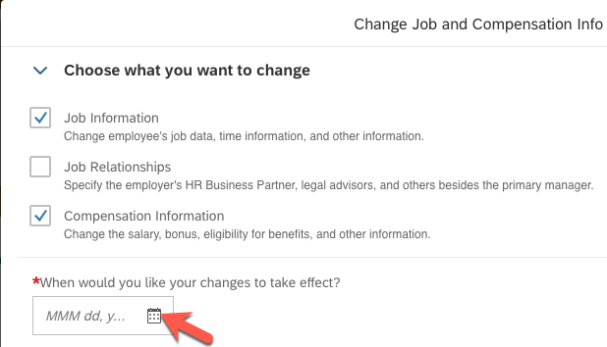

Changing Job Information
Scroll to the Job Information header.  Change the Job Classification and Position Title in that order.  Upon changing the Job Classification, other information will automatically update (i.e. Employee Class, Job Title, etc.  If you are changing a position from salaried to hourly or from hourly to salaried, you will need to select the appropriate Employment Type.  It’s important to note that you should never change the Position under the Position Information section (section that is two sections before the Job section). That moves the employee to a completely different position. For the No Transfer actions, we do not want them changing positions, only Jobs. The only position related item they should change is the Position Title in the Job Section. | 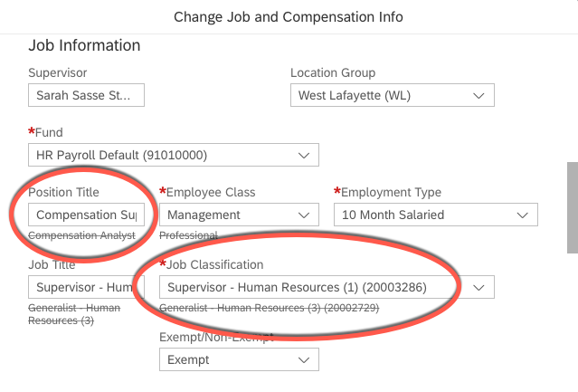

Changing Compensation Information
Skip this step if pay changes are not needed.
If a pay change is associated with the promotion, scroll down to the Compensation section.
Change the Pay Component if a change to the frequency is needed. (changing this field will auto-populate the Frequency field).
Change the Amount if a new monthly salary or hourly rate is needed.
If you are changing from salaried to hourly, make sure the Pay Component is changed to Hourly (1005) and type the hourly rate into the Amount box.
If you are changing from hourly to salaried, make sure the Pay Component is changed to A-Base Salary (1000) and type the monthly rate into the Amount box.
Click Save.
A pop-up box may appear as a warning if you changed the FTE or the Employment Type. If this occurs, you will need to reselect the Pay Component (click on Correct and reselect the Pay Component). If you did NOT make changed
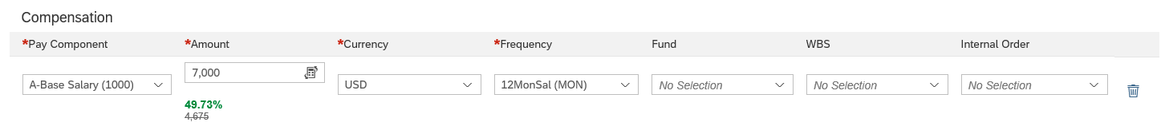
The confirmation box appears. Make sure the reason listed is No Transfer with or without Pay Increase for XXXX.  Click on Show workflow participants to view who is required to approve the request.  Click Confirm to initiate the workflow. | 